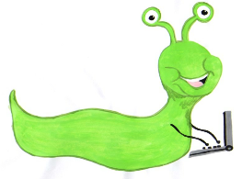

Lyng Primary School Knowledge Organiser

Information Technology



Summer 2

Stop motion

Year 2

Topic: IT

|  |  |
| --- | --- |
| What Goldilocks and Step On words will I use? | |
| **Spelling** | **Defintion** |
| Animation | The technique of photographing successive dawings or positions of puppets or models to convey the illusion of movement when the film is shown as a sequence. |
| Background | The part of a picture, scene or design that formas a setting for the main figures, or objects, or appears furthest from the viewer. |
| Filming | To capture on film as part of a series of moving images |
| Narrate | Tell the story of the video clip. |
| Stop motion | A technique where the camera is repeatedly stopped and started, for example, to give animated figures the impression of movement. |
| Storyboards | A plan of the animation produced as a series of drawings. |
| Video | Medium that was used to watch films. |

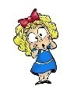

**Aims of this unit**

* Understand what stop motion animation is.
* Plan a stop motion video, thinking about the characters that are going to be used.
* Creating a stop motion animation and include a second character.
* Watch and discuss completed animations.
* Evaluate what went well and next steps.

**Safeguarding**

Filtering and monitoring system is in place. Children will use their own log in details to track any misuse and to protect the child from harmful websites and pop ups. Children will be reminded of how to stay safe online and to use technology safely and respectfully and to tell a trusted adult if there is anything on their computer that makes them uncomfortable. When using the iPads, the monitoring software will track which iPad has been used to enable us to know which class has used the iPad.

|  |
| --- |
| Outcomes |
| **All children**   * Learn from errors in filming in order to improve a stop motion film. * Work with a group to plan out animation. * Refer back to a storyboard to ensure the film is progressing according to the plan.   **Most children**   * Create a simple storyboard to plan out an animation. * Create short stop motion with small changes between images. * Make small movements between frames to create animation   **Some children**   * Storyboard two or more scenes that would be animated. * Create an animation which includes two objects that both move between the individual frames. * Ensure that there is a smooth animation by editing completed work. |

Summer term 2

Stop motion

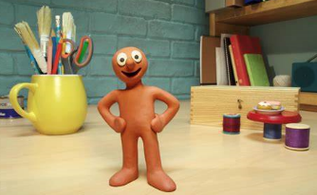

**In this unit…**

In this unit children will look at how animation is created and will have the opportunity to use plasticine in order to film their own. They will plan their work by creating a storyboard and will work in groups in order to plan out the events of their work.

**Agreed outcome:**

Create a short video clip with a plasticine character.